Model Predictive Control

Makes following a trajectory an optimization problem. Involves:

1) Simulating different actuator inputs
2) Predicting the resulting trajectory
3) Selecting the trajectory with the minimum cost

With a reference trajectory and our vehicles current state, we optimize our actuator inputs at each step in time to minimize the cost of our predicted trajectory.

Once we have the lowest cost trajectory, we can then implement the first set of actuation commands.
Then we can throw away the rest of the trajectory we calculated, and use our new state to estimate a new optimal trajectory.

We are constantly inputs over a future horizon, which is why this approach is sometimes called Receding Horizon Control.

The reason why we keep trying to find a new optimal trajectory is because our model is only approximate and wont accurately predict the location of the vehicle given some actuator inputs.

We can optimize based on a cost function that is made up of the errors we would like to minimize when compared to the reference trajectory. That way when we can use multiple actuator inputs to estimate multiple trajectories, and use the set of inputs that results in the trajectory with the lowest cost.

An example of one error that we can include in the cost function is the offset from the center of the lane, where the center of the lane is the reference, or desired, state.

Two errors we previously captured in our state where the cross track error (CTE) and the phi error, which is the difference in heading between the predicted trajectory and the reference trajectory.

When both of these errors are 0, there is no difference between the actual vehicle position, and the heading to the desired position and heading.

Making the Cost Function

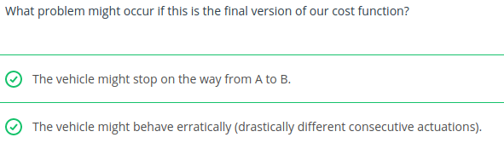
An example of how we can increment our cost function at each time step that is a good start but not quite enough is:
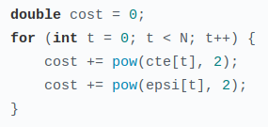

The vehicle might stop because if the vehicle reaches the optimal position and heading, there is no motivation to minimize the cost any further.

To solve this, we can use the simple solution which is setting a reference velocity. The cost function will penalize the vehicle for not maintaining the velocity.
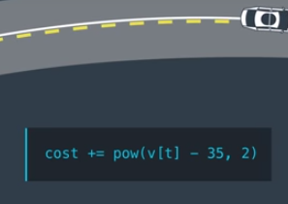
In this case we have a reference velocity of 35 km/h.

Another solution is to measure the Euclidean Distance between the current position of the vehicle and the destination, and add that distance to the cost.
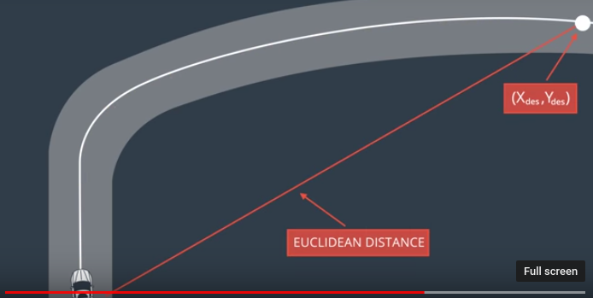

There are however many alternatives that may work better.

We can add also consider things other than the state in the cost function, like the control inputs.

This would allow us to penalize the magnitude of the control input as well as its change rate.
Example: If we want to change lanes, we would have a large cross track error. So we would want to penalize turning the wheel sharply, which would make the lane change more smooth.

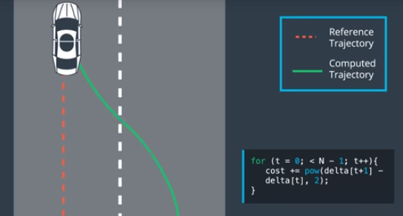
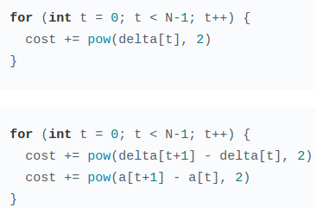
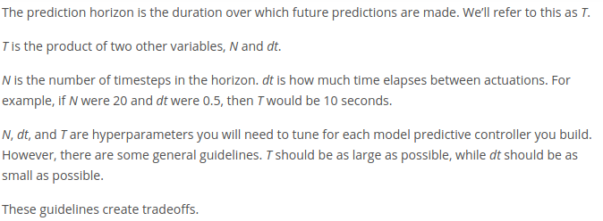
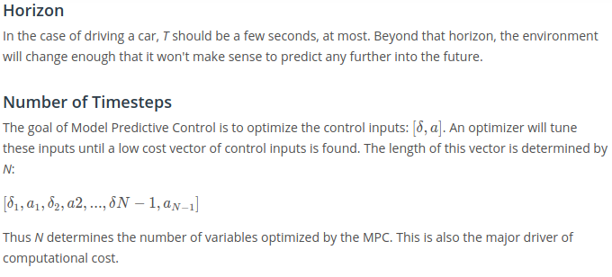
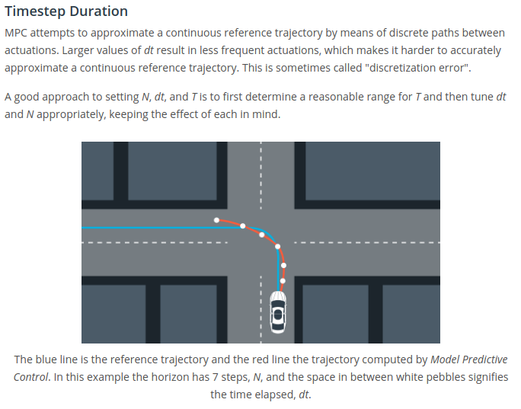

Putting it all Together

Model predictive control uses an Optimizer, to find the control inputs that minimize the cost function we created. We then only execute the first set of control inputs, and then optimize the vehicles control inputs based on the cost function again in that new state. This means that at every state we will run the Optimizer to give us the control inputs that minimize the cost function.

Model Predictive Control Algorithm

1) We set up everything we need for the Model Predictive Control Loop, which are our Hyper Parameters, T, dt, and N. We will then have a defined duration of the reference trajectory.

2) We then define our Vehicle Model, and our Constraints (Actuator Limitations).

3) We define our Cost function that takes everything we want to minimize at each time step into account.

With all these setup, we can then begin our state feedback loop.

First step of the Loop is to pass the current state to the Model Predictive Controller. A Optimizer is then called that will take into account the current vehicle state, the model, constraints, and cost function we define in order to optimize actuator inputs.

The solver we are using is called Ipopt. (This library is a C++ Optimization Library).

With the vector of control inputs that minimize the cost function, we apply the first input to the actuator, and then repeat the Loop.

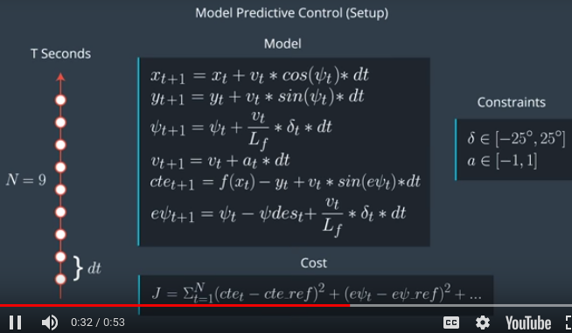

Latency

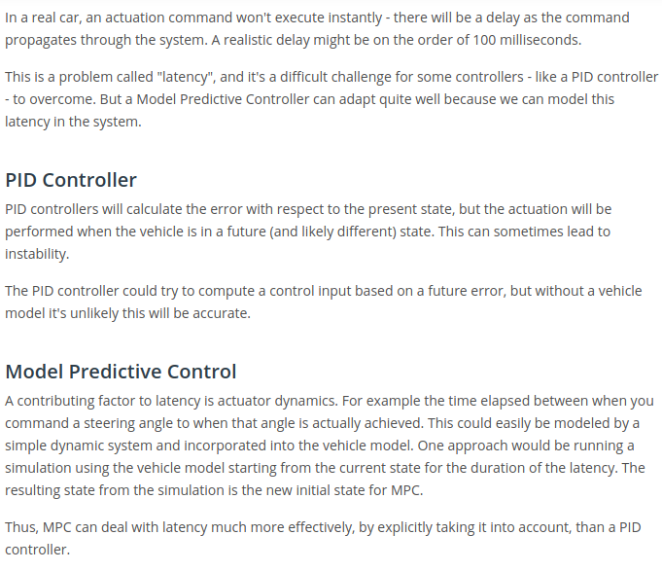

Model Predictive Control Quiz

